from: Robert W Malone MD from "Who is Robert Malone" <rwmalonemd@substack.com>

reply-to: Robert W Malone MD from Who is Robert Malone <reply+219l5m&doii8&&5cf53f421ac6e854808b8bca3697c622289f0801c463d90d54f54c4ecc250eae@mg1.substack.com>

to: fchase@gmail.com

date: May 22, 2023, 8:39 AM

subject: What Can The US Senate Teach Us about the Dangers of the COVID-19 Vaccines?

mailing list: rwmalonemd@substack.com Filter messages from this mailing list

mailed-by: mg1.substack.com

signed-by: mg1.substack.com

Keywords: smallpox (3 references), VAERS, mass (crowd) formation.

[**What Can The US Senate Teach Us about the Dangers of the COVID-19 Vaccines?**](https://substack.com/app-link/post?publication_id=583200&post_id=123059290&utm_source=post-email-title&isFreemail=false&token=eyJ1c2VyX2lkIjoyMjk3ODczNiwicG9zdF9pZCI6MTIzMDU5MjkwLCJpYXQiOjE2ODQ3NTkxNTIsImV4cCI6MTY4NzM1MTE1MiwiaXNzIjoicHViLTU4MzIwMCIsInN1YiI6InBvc3QtcmVhY3Rpb24ifQ._DOIxKhxmHUWtp3NVMOUL7X9WgQDxerOxguYymen_S4)

A review of the common forms of spike protein injuries and the profound consequences of denying them.

|  |  |  |  |  |  |  |
| --- | --- | --- | --- | --- | --- | --- |
| |  |  | | --- | --- | | |  | | --- | | [ROBERT W MALONE MD, MS](https://substack.com/redirect/9c653582-42ed-4b09-8056-eb94e9b4d90c?j=eyJ1IjoiZG9paTgifQ.91g_34VRuzI_MLkPmRIGM0gm4tNgR1dQS7br89dPnSg) | | | |  | | --- | | MAY 22 |   , 2023 | | |  | | --- | |  | |

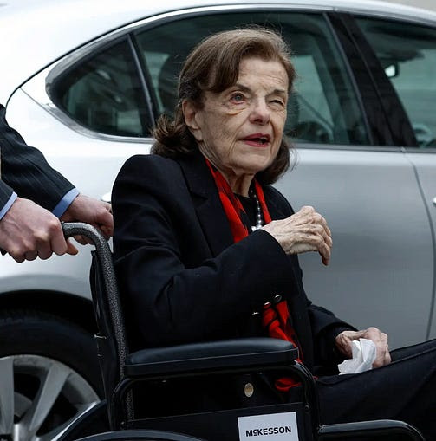

*[This email is] Reprinted by permission from the substack “*[*The Forgotten Side of Medicine*](https://substack.com/redirect/3eca019f-74c7-44e3-b003-8c0e3932e7b4?j=eyJ1IjoiZG9paTgifQ.91g_34VRuzI_MLkPmRIGM0gm4tNgR1dQS7br89dPnSg)*”, published by “A Midwestern Doctor”. The author [The Midwestern Doctor] is a personal friend of Dr. Pierre Koury, Ed Dowd, Steve Kirsch and myself, and his substack essays characteristically combine insights reflecting his deep understanding of both medicine and the human condition.*

Since the COVID-19 vaccines first came out, I have had many vaccine-injured patients, friends have contacted me about relatives who died suddenly, and I’ve spent an immense amount of time reading vaccine injury reports online. Once it became apparent that none of my colleagues would consider these concerns because they were trapped in a mass formation about the vaccines being 95% effective and our salvation from the pandemic, I felt trapped and hopeless.

Before long, I *[The Midwestern Doctor]* could at least meticulously confirm and document each injury I came across. I was unsure if it would ultimately lead to anything, but I had a strong feeling that, for some reason, I needed to do it. I then rationalized this hunch under the logic that making a log would give me a better sense of if the reports I saw online were accurately describing the catastrophe that was unfolding, it would provide me with some form of proof I could show colleagues who insisted there was no evidence whatsoever the vaccines were harmful, and it was a way I could at least pay respect to those who were injured.

Ultimately, my intuition was correct, but not for any of the reasons I rationalized at the time ago (which has repeatedly been an important life lesson for me). Fifteen months ago, not knowing who I was, Steve Kirsch kindly agreed [to share an article](https://substack.com/redirect/5a7b5eab-cba3-49ea-bcff-2055991db851?j=eyJ1IjoiZG9paTgifQ.91g_34VRuzI_MLkPmRIGM0gm4tNgR1dQS7br89dPnSg) I felt the world needed to see. It argued what we were going through with the COVID vaccine (written at the time the trucker protests were happening in Canada) perfectly mirrored what had happened with the disastrous (and ineffective) smallpox vaccines almost 150 years ago.

However, in addition to sharing it, Kirsch also encouraged his readers to subscribe to my newly formed Substack (made solely to share the smallpox article). Not being sure what else to do with a newfound subscriber base, [I published the log](https://substack.com/redirect/114ee3bb-41d9-412d-9f70-7c1536ee6dd3?j=eyJ1IjoiZG9paTgifQ.91g_34VRuzI_MLkPmRIGM0gm4tNgR1dQS7br89dPnSg) I had put together over the last year. **It hit a nerve and went viral** (again, largely thanks to Steve’s help).

I share this story to illustrate that **I have taken the time to develop a detailed understanding of the COVID-19 vaccine’s toxicity**—something I believe was partly motivated by the fact pharmaceuticals have injured many people close to me and thus created a strong interest in understanding pharmaceutical toxicity.

With the COVID-19 vaccines, I have observed that their injuries fall into a few common patterns, and the myriad of symptoms you observe can normally be traced back to one or more of these creating the specific symptom:

1. Severe inflammation and autoimmunity throughout the body.

2. Circulatory obstruction throughout the body.

3. Immune suppression.

*Note:*[*a paper*](https://substack.com/redirect/b79039c1-1de0-4da4-a74b-90a91e203564?j=eyJ1IjoiZG9paTgifQ.91g_34VRuzI_MLkPmRIGM0gm4tNgR1dQS7br89dPnSg)*by Stephanie Seneff was published in a peer-reviewed journal on* ***May 2021*** *(a few months after the COVID-19 vaccines hit the market). It recognized the signals that accurately predicted the first and third items would be major vaccine issues. It is****inexcusable****that an independent researcher with access to limited data could do this, yet our healthcare and scientific authorities could not.*

<*Editors note: this is a clear inditement of the WHO, US HHS, and the medical establishment in US, Canada, Europe, Australia, and most of the western world. For those who seek evidence supporting accusations of “crimes against humanity”, the clear documentation that the suppressed “dissident” voices were actually correctly interpreting the data in real time is a pretty good start.*>

I *[The Midwestern Doctor]* believe **the first problem** is a property of the spike protein being extremely immunogenic (which may in part be due to it [collapsing the zeta potential of the body](https://substack.com/redirect/2abf9196-ed52-4938-9250-8498a419c1bc?j=eyJ1IjoiZG9paTgifQ.91g_34VRuzI_MLkPmRIGM0gm4tNgR1dQS7br89dPnSg)), the spike protein [having homologies](https://substack.com/redirect/b79039c1-1de0-4da4-a74b-90a91e203564?j=eyJ1IjoiZG9paTgifQ.91g_34VRuzI_MLkPmRIGM0gm4tNgR1dQS7br89dPnSg) to a variety of human tissue (thereby creating autoimmunity to those tissues) and vaccines being designed so that the immunogenic spike protein is expressed on the surfaces of tissue, thereby causing the immune system to attack the mRNA transfected tissues.

<*Editors note: The cationic lipid nanoplexes also impact on zeta potential, and may play a role in this potential mechanism of toxicity.*>

There are many different approaches to this issue. Some of those colleagues and I use are addressing [the cell danger response](https://substack.com/redirect/d63cdeb3-ac12-48ee-911c-b49081019a0b?j=eyJ1IjoiZG9paTgifQ.91g_34VRuzI_MLkPmRIGM0gm4tNgR1dQS7br89dPnSg) and utilizing certain [oxidative therapies](https://substack.com/redirect/c944cf21-cfbc-428a-b2f4-ba5faec7feee?j=eyJ1IjoiZG9paTgifQ.91g_34VRuzI_MLkPmRIGM0gm4tNgR1dQS7br89dPnSg) (along with a few other methods also detailed [here](https://substack.com/redirect/c944cf21-cfbc-428a-b2f4-ba5faec7feee?j=eyJ1IjoiZG9paTgifQ.91g_34VRuzI_MLkPmRIGM0gm4tNgR1dQS7br89dPnSg)).

I *[The Midwestern Doctor]* believe **the second problem** is a property of the spike protein [collapsing the zeta potential of the body](https://substack.com/redirect/2abf9196-ed52-4938-9250-8498a419c1bc?j=eyJ1IjoiZG9paTgifQ.91g_34VRuzI_MLkPmRIGM0gm4tNgR1dQS7br89dPnSg), it [frequently attacking the lining of the blood vessels](https://substack.com/redirect/60fd92c8-db83-430e-9d88-91cc9f945be7?j=eyJ1IjoiZG9paTgifQ.91g_34VRuzI_MLkPmRIGM0gm4tNgR1dQS7br89dPnSg), and it being well suited [to creating misfolded proteins](https://substack.com/redirect/000b692b-c415-4a71-9f4a-1c872a6717e1?j=eyJ1IjoiZG9paTgifQ.91g_34VRuzI_MLkPmRIGM0gm4tNgR1dQS7br89dPnSg). These complications tend to respond to [restoring the zeta potential of the body](https://substack.com/redirect/c944cf21-cfbc-428a-b2f4-ba5faec7feee?j=eyJ1IjoiZG9paTgifQ.91g_34VRuzI_MLkPmRIGM0gm4tNgR1dQS7br89dPnSg), using [regimens](https://substack.com/redirect/c944cf21-cfbc-428a-b2f4-ba5faec7feee?j=eyJ1IjoiZG9paTgifQ.91g_34VRuzI_MLkPmRIGM0gm4tNgR1dQS7br89dPnSg) that can remove the fibrous clots, utilizing various anticoagulants (and repurposed drugs [which disperse](https://substack.com/redirect/7cf02460-cb2f-41b2-bfe7-5406566b568f?j=eyJ1IjoiZG9paTgifQ.91g_34VRuzI_MLkPmRIGM0gm4tNgR1dQS7br89dPnSg) spike protein microclots), and using therapies that create new blood vessels in the body.

**The third problem, immune suppression,** causes a variety of issues such as (often aggressive and unusual) cancers (which may also be due to [the spike protein entering the nucleus](https://substack.com/redirect/3aef7b20-932a-4e17-a077-1c43699823f6?j=eyJ1IjoiZG9paTgifQ.91g_34VRuzI_MLkPmRIGM0gm4tNgR1dQS7br89dPnSg)), far more frequent cases of the flu and other viral infections, reactivation of latent viruses, and sometimes [severe illnesses](https://substack.com/redirect/010934df-8d76-4a34-939d-c3fd2f224c35?j=eyJ1IjoiZG9paTgifQ.91g_34VRuzI_MLkPmRIGM0gm4tNgR1dQS7br89dPnSg) typically only seen in those with severe immune suppression (e.g., AIDS). Of the three problems listed, the treatment protocol for immune suppression is the least clearcut, and at this point, most of the approaches I’ve seen utilized are ones that target the first two in the hope they will also help for the third.  
  
*Note: one of my [The Midwestern Doctor] friend’s fathers died from the same fungal pneumonia (typically only seen in AIDS patients)*[*detailed by the ICU doctor above*](https://substack.com/redirect/010934df-8d76-4a34-939d-c3fd2f224c35?j=eyJ1IjoiZG9paTgifQ.91g_34VRuzI_MLkPmRIGM0gm4tNgR1dQS7br89dPnSg)*.*

**Shingles and Spike Proteins**

After you have a chickenpox infection, the virus will become dormant in your system and can reactivate later in life (especially if your immune system weakens) as shingles. Typically the reactivation is much worse than the initial infection (shingles can be extremely unpleasant), so various approaches, such as vaccines for shingles, are always being investigated and promoted.

<*Editors note: Historic fact- the reactivation of latent DNA viruses including shingles was known by my colleagues at the FDA in the office of the Commissioner and the Office of the Chief Scientist very early on, and we discussed it frequently on our weekly zoom calls. This is also the group that first identified the myocarditis adverse event signal. Both of these adverse events were disregarded by the review branch when they were initially notified.*>

*In areas where this was studied (the CDC commissioned studies as they believed chickenpox vaccination would decrease shingle), shingles instead became much more common (and appeared in younger age groups). The*[*best explanation put forward*](https://substack.com/redirect/af874528-b74f-490c-9903-2f35594c4924?j=eyJ1IjoiZG9paTgifQ.91g_34VRuzI_MLkPmRIGM0gm4tNgR1dQS7br89dPnSg)*to explain this (since you would expect the vaccine to do the opposite) was that the chicken pox vaccine creating partial immunity in the population prevented members of the population from periodically having their immunity to the virus be boosted by subclinical exposures from members of their community.*

To quantify the impact of the CDC’s researcher’s findings (keep in mind that the immune suppression which leads to a susceptibility to shingles has significantly increased since the time of these findings):

[Goldman pointed](https://substack.com/redirect/4bc428df-a916-445c-a727-fa17ee01f20b?j=eyJ1IjoiZG9paTgifQ.91g_34VRuzI_MLkPmRIGM0gm4tNgR1dQS7br89dPnSg) out that during a 50-year time span, there would be an estimated additional 14.6 million (42%) shingles cases among adults aged less than 50 years, presenting society with a substantial additional medical cost burden of $4.1 billion. This translates into $80 million annually, utilizing an estimated mean healthcare provider cost of $280 per shingles case.

Sadly, the CDC researcher’s findings [were not positively received](https://substack.com/redirect/654237b1-1793-4df0-8317-d5985a438758?j=eyJ1IjoiZG9paTgifQ.91g_34VRuzI_MLkPmRIGM0gm4tNgR1dQS7br89dPnSg). He received cease and desist orders and eventually had to leave the CDC.

*Note: much more has been written on this subject within*[*this book*](https://substack.com/redirect/a02a90cc-b15a-4431-a7a2-32bc92e2436f?j=eyJ1IjoiZG9paTgifQ.91g_34VRuzI_MLkPmRIGM0gm4tNgR1dQS7br89dPnSg)*.*

When the COVID-19 vaccines came out, **one of the first things**[**that raised red flags to independent researchers**](https://substack.com/redirect/b79039c1-1de0-4da4-a74b-90a91e203564?j=eyJ1IjoiZG9paTgifQ.91g_34VRuzI_MLkPmRIGM0gm4tNgR1dQS7br89dPnSg)**was shingles being a frequently reported adverse effect of the vaccines.**

We believe the occurrence of zoster is **another** important ‘signal’ in VAERS. This increased risk to shingles, if valid, may have important broader implications. Multiple studies have shown that patients with either primary or acquired immune deficiency are more susceptible to severe herpes zoster infection. This suggests that the mRNA vaccines may be suppressing the innate immune response.  
  
There is cross-talk between TNF- α and type I interferon in autoimmune disease, wherein each suppresses the other. Type I interferon inhibits varicella-zoster virus replication (Ku et al., 2016). TNF- α is sharply upregulated in an inflammatory response, which is induced by the lipid nanoparticles in the vaccine. Its up-regulation is also associated with the chronic inflammatory state of rheumatoid arthritis. Exuberant TNF-α expression following vaccination may be interfering with the dendritic cell INF-α response that keeps latent herpes zoster in check.

The spike in shingles suggested the COVID-19 vaccines were causing suppression of the innate immune system. This is that has been seen with previous vaccines, **but not to the degree witnessed with the COVID-19 vaccines.**

*<Editors note: Likewise the spike in EBV reactivation, which many physicians believe to be one of the major contributing causes to the “post vaccination syndrome”.>*

**The Distribution of Adverse Reactions**

Anytime something causes an injury to the body (assuming it is not something extreme like a nuclear blast), each person's response will vary, with less severe injuries being much more common than severe reactions. Conversely, if an injury pattern exists, which can be mild, moderate, or severe in its presentation, and you see a disproportional number of severe reactions (this is quite rare), that serves as a warning the toxin in question is extremely dangerous and that a much larger undetected number of mild and moderate injuries are also occurring.

When the cases of shingles began emerging, one of my first questions was, "Will we see the much rarer and more dangerous cases of it as well?"

**Then, in June of 2022, arguably the most famous celebrity in the world, Justin Bieber, had just that happen to him and developed Ramsay Hunt syndrome (a very rare form of shingles that paralyzes your face).**

I *[The Midwestern Doctor]* did [some digging on this subject](https://substack.com/redirect/af874528-b74f-490c-9903-2f35594c4924?j=eyJ1IjoiZG9paTgifQ.91g_34VRuzI_MLkPmRIGM0gm4tNgR1dQS7br89dPnSg) and found out the following:

•Based on the available literature, Justin Bieber had a 27/1,000,000 chance of developing this condition.

•Justin Bieber [was almost certainly](https://substack.com/redirect/af874528-b74f-490c-9903-2f35594c4924?j=eyJ1IjoiZG9paTgifQ.91g_34VRuzI_MLkPmRIGM0gm4tNgR1dQS7br89dPnSg) vaccinated.

•Justin Bieber had previously recovered from Lyme disease, which may have created his susceptibility to this condition.

When I looked at the broader context, I discovered that:

•Both [Moderna](https://substack.com/redirect/698ecbf1-9ab8-4875-8e06-79f7393e1cb1?j=eyJ1IjoiZG9paTgifQ.91g_34VRuzI_MLkPmRIGM0gm4tNgR1dQS7br89dPnSg) and [Pfizer](https://substack.com/redirect/00a55626-5fe4-4c7f-bee0-42f69012004a?j=eyJ1IjoiZG9paTgifQ.91g_34VRuzI_MLkPmRIGM0gm4tNgR1dQS7br89dPnSg) were well into developing mRNA vaccines for shingles despite a traditional vaccine already being on the market.

•Opthamalogists were observing an increase in Ramsay Hunt syndrome, a condition that is typically referred to opthamalogy specialists, but it is so rare that most of them (including a close friend of mine) had never seen it in their careers. This statement for example came from an ophthalmologist I verified was who they claimed they be.

[Text only replication: Neil Chesen MD "In the past month I have seen four cases of Ramsey-Hunt Symdrome, which is shingles involving ear and facial nerve. Never saw a single case in 32 years of practice. All vaxed, three boosted 2-3 months prior. Very odd.]

|  |  |  |
| --- | --- | --- |
|  |  |  |

•Both shingles and the severe complications of it, in turn, have been elevated following COVID-19 vaccination. The following table is from the most comprehensive [article](https://substack.com/redirect/22b936a3-dca6-4271-a258-58822c539be9?j=eyJ1IjoiZG9paTgifQ.91g_34VRuzI_MLkPmRIGM0gm4tNgR1dQS7br89dPnSg) I was able to find on the subject:

[See link for table.]:

What I found most disappointing about these events was Bieber’s choice not to speak out about what had happened and risk his career to do the right thing. This was particularly disappointing given that Bieber had previously publicly spoken out on the issue of Lyme disease, a condition that is marginalized and neglected by the medical community, and which many patients suffer with for years.

**How Dangerous Are The COVID-19 Vaccines?**

Typically, the adverse rates of a dangerous pharmaceutical are rare enough that, while unacceptably high, they are usually possible to sweep under the rug. **The COVID-19 vaccines are somewhat unique in this regard because they were given out of the blue to most of the world’s population (making it much easier to recognize their impact) and were clearly associated with an unprecedented incidence of post- inoculation adverse events.** Thus, even though most of the media and academic press did their best to cover it up, much of the public saw through these lies. Two of the best resources I saw for demonstrating the overall harm of this vaccination campaign were as follows:

**First,** Edward Dowd assembled a team of experienced analysts that worked to calculate the costs of the vaccine program. Recently they [released a report](https://substack.com/redirect/5586503e-5a6a-4172-b495-2d1cda16500a?j=eyJ1IjoiZG9paTgifQ.91g_34VRuzI_MLkPmRIGM0gm4tNgR1dQS7br89dPnSg) which speaks for itself:

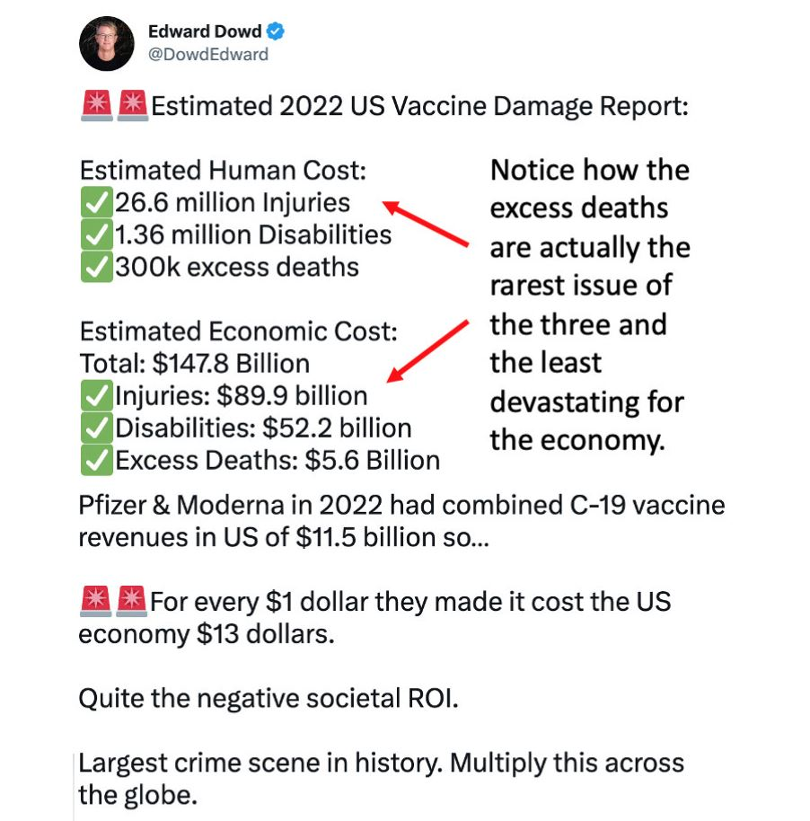

|  |  |  |
| --- | --- | --- |
|  |  |  |

**When I reviewed Dowd’s report, I realized there were a lot of human and economic costs that the report was not counting, presumably since they are impossible to calculate precisely.** This means **this report underestimated** the harms that have been caused by the vaccine program.

**Secondly**, Rasmussen Reports, one of the more honest political polling firms, recently conducted [two surveys](https://substack.com/redirect/149fad6a-0693-449a-a94a-5cb4d3dfd6e6?j=eyJ1IjoiZG9paTgifQ.91g_34VRuzI_MLkPmRIGM0gm4tNgR1dQS7br89dPnSg) on the scope of vaccine injury:

Rasmussen 1

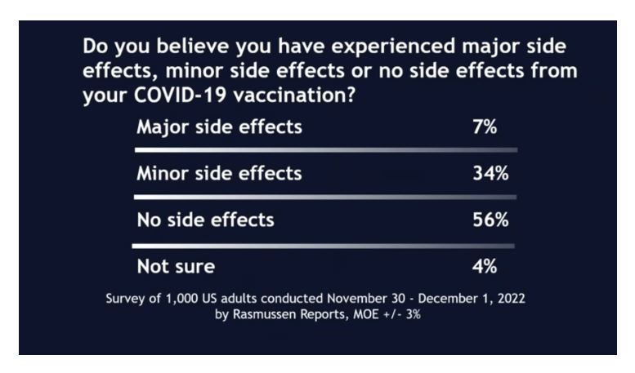

|  |  |  |
| --- | --- | --- |
|  |  |  |

*Note: based on all the other figures I have examined, I do not believe “major” was an exaggeration by the survey participants.*

*Rasmussen 2*

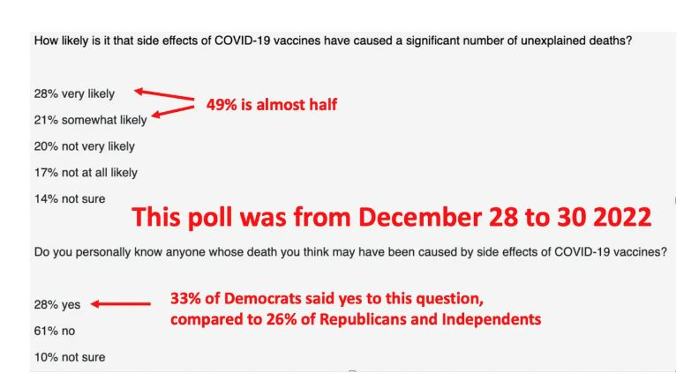

|  |  |  |
| --- | --- | --- |
|  |  |  |

Each of these assessments demonstrates that the damage from the COVID vaccines is on a scale that the general public is fully aware of, despite [the massive amounts of propaganda](https://substack.com/redirect/473c92b9-ef96-4251-ae71-977200cf0c69?j=eyJ1IjoiZG9paTgifQ.91g_34VRuzI_MLkPmRIGM0gm4tNgR1dQS7br89dPnSg) telling them otherwise.

*Note: Rasmussen has also conducted*[*additional polls*](https://substack.com/redirect/a010bcee-542c-404e-aeb3-4a3f61033950?j=eyJ1IjoiZG9paTgifQ.91g_34VRuzI_MLkPmRIGM0gm4tNgR1dQS7br89dPnSg)*on this subject that had results similar to the polls above.*

**Democratic Senators**

Given the high rate of significant COVID-19 vaccine injuries, two possibilities seem quite plausible.

1. The first is that the COVID-19 vaccines have also injured numerous public officials.
2. The second is that if those officials pushed for mandating the COVID-19 vaccines on the population, like Justin Bieber, they would likely try to cover up their injury rather than speak out on the issue.

For example, Illinois Democrat and US Representative Sean Casten’s 17-year-old daughter Gwen died suddenly and unexpectedly in her sleep Sunday night, June 12, 2022. For context, prior to the vaccines, a sudden death in an adolescent was extraordinarily rare. When [independent journalists investigated the events](https://substack.com/redirect/ca6ab604-7103-44e4-b158-be7f436ef594?j=eyJ1IjoiZG9paTgifQ.91g_34VRuzI_MLkPmRIGM0gm4tNgR1dQS7br89dPnSg), they found both that

1. Casten’s family aggressively promoted the vaccine and that
2. there was a high likelihood one killed his daughter.

However, rather than supply any information to dispel these rumors, Casten [in a statement](https://substack.com/redirect/1d7baae9-8184-487d-8abd-9a977a6b09f8?j=eyJ1IjoiZG9paTgifQ.91g_34VRuzI_MLkPmRIGM0gm4tNgR1dQS7br89dPnSg), simply said:

“The **only thing we know** about her death is that it was peaceful. And the **only lesson** we can take from that is to savor the moments you have with your loved ones.”

*Note: quite a few parents took strong exception to how Casten handled this, and sadly there are other*[*similar examples*](https://substack.com/redirect/14a800bd-7754-4fcb-9511-be21b96b5f1d?j=eyJ1IjoiZG9paTgifQ.91g_34VRuzI_MLkPmRIGM0gm4tNgR1dQS7br89dPnSg)*I can also cite of the “Casten Response.”*

In addition to Casten, there have been many other suspicious incidents strongly suggestive of COVID-19 vaccine injury existing throughout the Democratic leadership (that included prolonged and conspicuous absences) and of those injuries being covered up.

**The best sample I have come across can be found in the U.S. Senate.** Briefly, since the vaccines entered the market:

**A)** [**Ben Ray Luján**](https://substack.com/redirect/a990acff-ec8e-4f6c-8d41-9e618b5c548c?j=eyJ1IjoiZG9paTgifQ.91g_34VRuzI_MLkPmRIGM0gm4tNgR1dQS7br89dPnSg) is a freshman New Mexico Democratic Senator [who repeatedly promoted the COVID-19 vaccines](https://substack.com/redirect/fa6dbafb-4e61-458f-b515-2077bf533561?j=eyJ1IjoiZG9paTgifQ.91g_34VRuzI_MLkPmRIGM0gm4tNgR1dQS7br89dPnSg):

On January 27, 2022, Luján (then 49) was hospitalized in Santa Fe after feeling fatigued and dizzy. He was found to have had a stroke affecting his cerebellum and was transferred to the University of New Mexico Hospital for treatment, which included a [decompressive craniectomy](https://substack.com/redirect/f5dc1684-ef7c-48e4-aff3-04dc98315712?j=eyJ1IjoiZG9paTgifQ.91g_34VRuzI_MLkPmRIGM0gm4tNgR1dQS7br89dPnSg). A statement from his office said that "he is expected to make a full recovery".Luján returned to work at the Senate on March 3 and stated by April 21 that he was 90% recovered.

**B) Jon Fetterman**, a freshman Pennsylvania Democratic Senator (then aged 52) on May 17, 2022, [less than a month after strongly endorsing the vaccine](https://substack.com/redirect/4503918f-ae3c-4f04-8500-4aac8a4ae71b?j=eyJ1IjoiZG9paTgifQ.91g_34VRuzI_MLkPmRIGM0gm4tNgR1dQS7br89dPnSg), suffered a stroke two days before the state primary for his senate seat. Despite significant signs of cognitive impairment since his stroke, Fetterman somehow won the primary and then the general election. Since becoming elected, Fetterman [has had](https://substack.com/redirect/f02b3114-80e1-4a91-ba94-dd108ce737f5?j=eyJ1IjoiZG9paTgifQ.91g_34VRuzI_MLkPmRIGM0gm4tNgR1dQS7br89dPnSg) prolonged periods of absence from the U.S. Senate due to needing specialized medical care:

Fetterman was hospitalized for [syncope](https://substack.com/redirect/01865c8c-0e08-499a-bd3f-d218d8f40f17?j=eyJ1IjoiZG9paTgifQ.91g_34VRuzI_MLkPmRIGM0gm4tNgR1dQS7br89dPnSg) (lightheadedness) for two days beginning on February 10, 2023.Two days after his release he was hospitalized again, for a severe case of major depression. For about two months, Fetterman lived and worked at the Walter Reed Army Medical Center.As part of his daily schedule at the hospital, his chief of staff arrived at 10 a.m. on weekdays with newspaper clips, statements for Fetterman to approve, and legislation to review. During his hospitalization, Fetterman co-sponsored a bipartisan rail safety bill, introduced after the derailment of a chemical-carrying train in East Palestine, Ohio, close to the border with Pennsylvania; the regulation aimed to strengthen freight-rail safety regulations to prevent future derailments.

On April 17, 2023, Fetterman returned to the Senate to chair the Senate Agriculture, Nutrition and Forestry subcommittee on food and nutrition, specialty crops, organics and research.*The Washington Post* said that Fetterman's "voice stumbled at times while reading from prepared notes" during the subcommittee hearing, but "he appeared in good spirits" and communicated a message about the importance of fighting hunger.

It is also important to consider that in addition to strokes being one of the most common complications of the COVID-19 vaccines, both Luján and Fetterman were at an age where unexpected strokes are fairly rare.

|  |  |  |
| --- | --- | --- |
|  |  |  |

*I would argue that both of these events occurring not long after the vaccines entered the market (to a 49-year-old and a 52-year-old within a group of 48 people) was so unlikely that it cannot be attributed to chance.*

However, while those two senators' stories are compelling,   
  
**C) Dianne Feinstein**'s is the most important one in my opinion.

[In late February](https://substack.com/redirect/16981d4f-0fdd-417b-9184-ee8c820125c5?j=eyJ1IjoiZG9paTgifQ.91g_34VRuzI_MLkPmRIGM0gm4tNgR1dQS7br89dPnSg), Dianne Feinstein was hospitalized for shingles. To quote [Steve Kirsch's investigation](https://substack.com/redirect/76209b00-660f-4109-8201-7c554bdbf32a?j=eyJ1IjoiZG9paTgifQ.91g_34VRuzI_MLkPmRIGM0gm4tNgR1dQS7br89dPnSg) of his California senator:

The [article in the *San Jose Mercury News*](https://substack.com/redirect/16981d4f-0fdd-417b-9184-ee8c820125c5?j=eyJ1IjoiZG9paTgifQ.91g_34VRuzI_MLkPmRIGM0gm4tNgR1dQS7br89dPnSg) said her office wouldn’t comment on her medical history regarding shingles due to privacy concerns.

But I’d like to know how keeping her history secret benefits the public.

She pushed the vaccines. Over and over. And over.

She even wanted to require vaccination or COVID tests for air travel.

We all know now how ludicrous such a suggestion was.

Given that shingles [typically does not require hospitalization](https://substack.com/redirect/65701601-13cb-49c5-b8b2-b3b7c90aa9da?j=eyJ1IjoiZG9paTgifQ.91g_34VRuzI_MLkPmRIGM0gm4tNgR1dQS7br89dPnSg), many assumed Feinstein had suffered a rare but severe complication of shingles like Ramsay Hunt Syndrome due to vaccine immune suppression. Her staff, of course, insisted nothing of concern had happened, and she would be able to return to work soon.

Unfortunately, **like Fetterman, a significant neurological injury occurred that became impossible to coverup once she returned, forcing Feinstein and her staff**[**to come clean about what happened**](https://substack.com/redirect/b54708d4-6d49-458c-8462-ca10c66549c5?j=eyJ1IjoiZG9paTgifQ.91g_34VRuzI_MLkPmRIGM0gm4tNgR1dQS7br89dPnSg)**:**

Adam Russell, a spokesman for Feinstein, said that the encephalitis, or inflammation of the brain, “resolved itself shortly after she was released from the hospital in March.” **Feinstein continues to have complications from the Ramsay Hunt syndrome, Russell said.**

Russell confirmed the two complications after the New York Times first reported them, raising questions about whether she had been hiding the extent of her illnesses. Upon her return last week, Feinstein was using a wheelchair and noticeably thinner, and has appeared confused at times when speaking to reporters or being wheeled through the halls.

“The senator previously disclosed that she had several complications related to her shingles diagnosis,” Russell said in the statement. “As discussed in the New York Times article, those complications included Ramsay Hunt syndrome and encephalitis.”

Feinstein’s face has appeared partially paralyzed since she returned to the Senate, stirring some speculation about whether she had had a stroke….Encephalitis can also be caused by shingles. The swelling of the brain can have a number of different symptoms, including personality changes, seizures, stiffness, confusion and problems with sight or hearing, according to the Mayo Clinic.

Aides to Feinstein said last week that she is still recovering from her illness and would operate on a reduced schedule. Since she has returned, she has missed some votes where she was not needed. On Wednesday, for example, she missed the first three Senate votes of the day but appeared for the last two, in which the margin was much closer.

While this speaks for itself, the one additional detail I wish to highlight is that, as the above compilation of vaccine injuries shows, encephalitis is a much rarer complication of shingles than the already rare Ramsay Hunt syndrome.

One of the potential complications of this infection is involvement of the central nervous system causing encephalitis. An increased risk of this complication is associated with the immunocompromised patient….According to the World Health Organization, encephalitis occurs in one out of every 33,000–50,000 cases of VZV [shingles].

**Conclusion**

I am relatively sure other prominent leaders and members of the senate besides Luján, Fetterman, and Feinstein have had significant COVID-19 vaccine injuries—the only difference being that **they were possible to cover up because they did not prevent the senator from being able to appear to do their job.** However, if we assume those three were the only ones injured and assume that all Democrat senators vaccinated themselves, given that there are presently 48 Democratic senators, this represents a 6.25% rate of severe injury following COVID-19 vaccination.

This figure is both in line with the 7% rate of “major” injury following vaccination Rasmussen survey respondents reported and [Ed Dowd’s conservative estimate](https://substack.com/redirect/6539415f-4ad7-42b3-9b87-c741190e8ec2?j=eyJ1IjoiZG9paTgifQ.91g_34VRuzI_MLkPmRIGM0gm4tNgR1dQS7br89dPnSg) of 18% of vaccine recipients suffering a complication from vaccination and 0.93% of vaccine recipients becoming disabled.

It is both utterly inexcusable that our political leaders would be pushing something this dangerous onto the population and also **quite perplexing they have continued to do so even after they’ve had first-hand experience with the COVID-19 vaccine’s devastating consequences.**

Recently (as part of a successful intervention for someone trapped within a cult), I rewatched a phenominal *[click 1]* [interview Mattias Desmet gave Tucker Carlson about](https://rumble.com/v2f18ec-march-27-2023.html?utm_source=substack&utm_medium=email) *[or click 2]* [Mass Formation](http://chasegalleryconnect.org/FNC_C/Data/People/Individuals/R/Robert%20W.%20Malone/Behavioral%20Control/). I *[The Midwestern Doctor]* believe this interview succinctly explains precisely why the Democrat leadership is behaving the way it is, and I would highly recommend you watch it because it touches on so many different critical points of the era we live in.

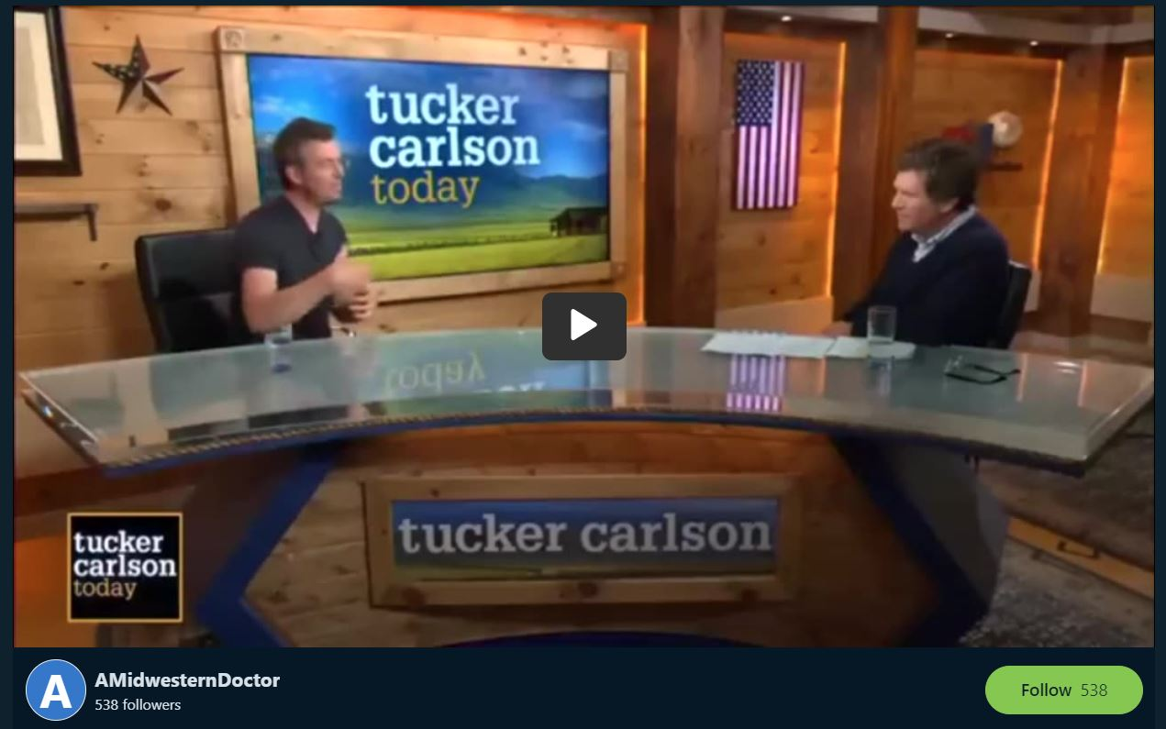

I *[The Midwestern Doctor]* thank you for taking the time to read this and Dr. Malone for helping to bring attention to these crucial issues.